Mixture Models for Single-Cell Assays with Application to Vaccine Studies

Greg Finak$^{1}$, Andrew McDavid$^{1}$, …, Steve De Rosa$^{1,2}$, Mario Roederer$^{3}$, and Raphael Gottardo$^{1,*}$  
$^{1}$Vaccine and Infectious Disease Division, Fred Hutchinson Cancer Research Center (FHCRC), Seattle, WA  
$^{2}$HIV Vaccine Trials Network, Fred Hutchinson Cancer Research Center (FHCRC), Seattle, WA  
$^{3}$Vaccine Research Center, NIAID, NIH, 40 Convent Drive, Rm 5509, Bethesda, MD 20892

*Received August* 2012.

[firstpage]

Blood and tissue are composed of many functionally distinct cell subsets. In immunological studies, these can only be measured accurately using single-cell assays. The characterization of these small cell subsets is crucial to decipher system level biological changes. For this reason, an increasing number of studies rely on assays that provide single-cell measurements of multiple genes and proteins from bulk cell samples. A common problem in the analysis of such data is to identify markers (or combinations of markers) that are differentially expressed between two biological conditions (*e.g.*, before/after vaccination), where expression is defined as the proportion of cells expressing that marker (or marker combination) in the cell subset(s) of interest. Here, we present a Bayesian hierarchical framework based on a beta-binomial mixture model for testing for differential marker expression using single-cell assays. Our model allows the inference to be subject specific, as is typically required when accessing vaccine responses, while borrowing strength across subjects through common prior distributions. We propose two approaches for parameter estimation: an empirical-Bayes approach using an Expectation-Maximization algorithm and a fully Bayesian one based on a Markov chain Monte Carlo algorithm. We compare our method against classical approaches for single-cell assays including Fisher’s exact test, a likelihood ratio test, and basic log-fold changes. Using several experimental assays measuring proteins or genes at the single-cell level and simulated data, we show that our method has higher sensitivity and specificity than alternative methods. Additional simulations show that our framework is also robust to model misspecification. Finally, we also demonstrate how our approach can be extended to testing multivariate differential expression across multiple marker combinations using a Dirichlet-multinomial model and illustrate this multivariate approach using single-cell gene expression data and simulations.

Mixture modelling, hierarchical modelling, bayesian modelling, single-cell assays, immunology

# Introduction

[s:intro] Cell populations, particularly in the immune system, are never truly homogeneous; individual cells may be in different biochemical states that define functional but measurable differences between them. This single-cell heterogeneity is informative, but lost in assays that measure cell mixtures. For this reason, endpoints in vaccine and immunological studies are measured through a variety of assays that provide single-cell measurements of multiple genes and proteins. In the 1970s, single-cell analysis was revolutionized with the development of fluorescence-based flow cytometry (FCM). Since then, instrumentation and reagent advances have enabled the study of numerous cellular processes via the simultaneous single-cell measurement of multiple surface and intracellular markers (up to 17 markers). More recent technological development have drastically extended the capabilities of single-cell cytometry to measure dozens of simultaneous parameters per cell . Although cells sorted using well-established surface markers may appear homogeneous, mRNA expression of other genes within these cells can be heterogeneous  and could further characterize and subset these cells. A new technology based on microfluidic arrays combined with multiplexed polymerase chain reactions (PCR) can now be used to perform thousands of PCRs in a single device, enabling simultaneous, high-throughput gene expression measurements at the single-cell level across hundreds of cells and genes . While classic gene expression microarrays sum the expression from many individual cells, the intrinsic stochastic nature of biochemical processes results in relatively large cell-to-cell gene expression variability . This heterogeneity may carry important information, thus single-cell expression data should not be analyzed in the same fashion as cell-population level data. Special treatment of single-cell level data, which preserves information about population heterogeneity, is warranted in general. For this reason, single-cell assays are an important tool in immunology, providing a functional and phenotypic snapshot of the immune system at a given time. These assays typically measure multiple markers simultaneously on individual cells in a heterogeneous mixture such as whole blood or peripheral blood mononuclear cells (PBMC), and are used for immune monitoring of disease, vaccine research, and diagnosis of haematological malignancies .

During analysis, cell level marker intensities are typically thresholded as positive or negative so that subsets with different multivariate combinations can be obtained as Boolean combinations. For some assays (*e.g.*, flow cytometry), the positivity thresholds are set based on prior biological knowledge while for others, thresholds are given by the assay technology. This is the case for the Fluidigm technology where genes are recorded as absent (not expressed) or present (expressed) at the single-cell level. After this thresholding step, we obtain a Boolean matrix of dimension where is the number of cells recorded and is number of markers. Using this matrix, one can form putative cell subsets obtained as Boolean combinations. When is large there is a combinatorial explosion of the number of subsets, and many of these might be small or even empty. A common statistical problem is, for a given marker combination, to identify subjects for whom the proportion of cells expressing that combination is significantly different between two experimental conditions (*e.g.*, before and after vaccination). Note that we use the term ‘subject’ throughout the paper, but the approaches described are general and can be applied to other experimental units (e.g. animal studies).

A motivating example from vaccine research is the flow cytometric intracellular cytokine staining (ICS) assay, which is used to identify and quantify subjects’ immune responses to a vaccine. Upon vaccination, antigen in the vaccine is taken up and presented to CD4 or CD8 T-cells via antigen presenting cells. While not all T-cells can recognize all antigens, those that recognize antigens in the vaccine become *activated* and produce a variety of cytokines, further promoting the immune response. After activation, this antigen-specific subpopulation proliferates and can persist in the immune system for some time providing *memory* that can more rapidly recognize the same antigen again in the future . These antigen-specific T-cell subpopulations constitute a very small fraction of the total number of CD4 and CD8 T-cells. The ICS assay measures the number of antigen-specific T-cells in PBMC or whole blood by measuring cytokine production in response to activation following stimulation by an antigen that closely matches what was present in the original vaccine. Individual cells are labelled using fluorescently conjugated antibodies against phenotypic markers (CD3, CD4, and CD8), used to subset T-cells, and functional markers (cytokines) used to define antigen specific T-cells . A sufficiently large number of cells must be collected to ensure that the rare cell populations can be detected. Subsequently, each individual cell is classified as either positive or negative for each maker based on predetermined thresholds, then the number of cells matching each subpopulation phenotype is counted.

These counts are compared between antigen stimulated and unstimulated samples from a subject to identify significant differences. Subjects who generate a response after stimulation are called *responders* whereas subject that do not show any differences are called *non-responders*. In many immunological studies, the size of the functionally distinct subpopulations (*i.e.*, the number of positive cells) is very low (relative to the total number of cells), and real biological differences might be difficult to detect.

Although there is no standard approach to analyzing ICS assays, current methods range from ad-hoc rules based on log-fold changes , to non–parametric methods , to permutation tests based on Hotelling’s T$^2$ statistics , to exact tests of 2x2 contingency tables (*e.g.*, Fisher’s exact test and test) . All of these methods test subjects separately, and no information is shared across observations even though one could expect some similarities across responders (*resp.* non-responders). The framework developed in this paper, named MIMOSA (Mixture Models for Single Cell Assays), addresses these issues explicitly. In our model, cell counts are modelled by a binomial (or multinomial in the multivariate case) distribution and information is shared across subjects by means of a prior distribution placed on the unknown proportion(s) of the binomial (or multinomial) likelihood. In order to discriminate between responders and non-responders, the prior is written as a mixture of two beta (or Dirichlet in the multivariate case) distributions where the hyper-parameters for each mixture component are shared across subjects. This sharing of information helps regularize proportion estimates when the cell counts are small, which is typical with single-cell assays, and increase sensitivity and specificity when detecting responders. Because our framework is multivariate in nature, multiple cell subsets can be model simultaneously, which could help detect small biological changes that are spread out across multiple cell subsets . Our paper is organized as follows, Section [s:data] introduces the data and notations used in the paper. In Section [s:DEone], we present our model for testing differential marker expression in the univariate case. Section [s:results] compares our approach to alternative methods and tests the robustness of our model. In Section [s:demarkercombos] we present a multvariate extension of our model that can be used to test multivariate marker differential expression and present some results using a single-cell gene expression data. Finally, in Section [s:discussion] we discuss our findings and future work.

# Data structure and notation

[s:data] In this paper we consider two types of immunological single-cell assays: flow cytometry and single-cell gene expression, as described below.

*Flow cytometry*: The primary dataset used here is an ICS data set generated as part of a trial testing the GeoVax DNA and MVA (Modified Vaccinia Ankara) HIV vaccine in a prime-boost regimen with 120 subjects . The goal of this data set was to assess the immune response to the vaccine across multiple stimulations, time points, cytokines and T-cell subsets. Here, we analyze a subset of the data consisting of 98 subject from the vaccine group at two time points, day 0 and day 182. Three cytokines (IFN, TNF and IL2) were measured at the single-cell level for each subject and time point, with and without stimulations with an antigen (HIV Envelope peptide pool) matching part of the vaccine. For ease of presentation we restricted ourselves to the CD4+ T-cell subsets. Samples on day 0 were taken just before vaccination and no response is expected there. The corresponding samples can be used as negative controls. Conversely, day 182 (26 weeks) should be close to the immunogenicity peak, and many subjects are expected to respond, for some cytokines at least.

*Fluidigm single-cell gene expression*: This is a single-cell gene expression data set of sorted CD8 T-cells from sixteen subjects. T-cells isolated by flow cytometry from sixteen subjects were stimulated in blocks of four subjects with four different antigens (HIV Gag, HIV Nef, CMV pp65 tm10, CMV pp65 nlv5) and gene expression post-stimulation measured at the single-cell level using the BioMark system (Fluidigm) well arrays. The expression from the simulated samples was compared to paired, unstimulated controls [1].

In the remainder of the paper, we use the following notation to describe our model. From this point on, we assume that we observe cell counts from subjects in two conditions: stimulated and un-stimulated. Each cell can either be positive or negative for a marker. Given a set of markers, the measured cells can be classified into positive/negative marker combinations. We denote by and , , the observed counts for the combinations in the stimulated and un-stimulated samples. We denote by and the total number of cells measured for subject in each sample. For ease of notations, we will denote by the vector of observed counts for subject , *i.e.* where and . Finally, we define .

# Differential expression with one marker

[s:DEone] Datasets like the ones presented here are usually analyzed in in a univariate fashion to avoid being underpowered due to the large number of combinations and the potential for very small cell counts in many of the combinations. Here, by univariate, we mean that we have only one positive cell subset. This cell subset can be defined by considering the expression of one marker alone (marginalizing over all other measured markers) such as IL2 (*vs.* IL2), or considering a specific positive marker combination (and marginalizing over everything else) such as IL2 and/or INF (*vs.* IL2/INF). Without loss of generality, we treat the univariate case as a one marker case (*i.e.* ). In this case, for a given subject, the data can be summarized in a contingency table of cell counts across the un-stimulated and stimulated samples as depicted in Table [tab:twobytwo].

For a given subject and stimulation, we consider a marker to be differentially expressed if the proportion of positive cells in the stimulated samples is different from the number of positive cells in the un-stimulated sample. Subjects that show differential expression will be called responders for that marker. In this section, we shall be concerned with identifying differential expression one marker at a time, using a beta-binomial mixture model as described in what follows.

## Beta-binomial model

[s:DE] For a given subject , the positive cell counts for the stimulated and un-stimulated samples are jointly modeled as follows,

$(n_{si}|p_{si}) \sim \mathrm{Bin}(N_{si},p_{si})\quad \text{and}\quad (n_{ui}|p_{ui}) \sim \mathrm{Bin}(N_{ui},p_{ui})\label{eq:bino_likelihood}$

where , are the unknown proportions for the stimulated and un-stimulated paired samples. In order to detect responding subjects, we consider two competing models:

${\cal M}_0: p_{ui}=p_{si}\quad \text{and}\quad {\cal M}_1: p_{ui}\ne p_{si}. \label{eq:models}$

Under the null model, ${\cal M}_0$, there is no difference between the stimulated and un-stimulated samples, and the proportions are equal. Under the alternative model, ${\cal M}_1$, there is a difference in proportions between the two samples and the subject is a responder. In some studies, such as the ICS data used here, the proportion of positive cells is expected to only increase after stimulation, in which case the alternative model should be defined as . This alternative parametrization is described in Web Appendix B and we refer to it as the one-sided model.

## Priors

[ss:priors] Our model shares information across all subjects using exchangeable Beta priors on the unknown proportions, as follows,

where is an indicator variable equal to one if subject is a responder, i.e. ${\cal M}_1$ is true, and zero otherwise, and are unknown hyper-parameters shared across all subjects. Note that the parameters are explicitly shared across the two models, whereas are only present in the alternative model. Finally, we assume that the ’s are independent and identically distributed Bernoulli with probability , where represents the (unknown) proportion of responders. It follows that marginally, *i.e.* after integrating , and are jointly distributed as a mixture of a one dimensional and a two dimensional Beta distributions with mixing parameter . Treating the ’s as missing data, the unknown parameter vector $\boldsymbol\theta\equiv(\alpha_u, \beta_u, \alpha_s,\beta_s, w)$ can be estimated in an Empirical-Bayes fashion using and Expectation-Maximization  algorithm as described in Section [s:estimation]. As an alternative, we also describe a fully Bayesian model where the hyperparameters and are given vague exponential priors with mean , and is assumed to be drawn from a uniform distribution between 0 and 1. In this case, all parameters will be estimated via a Markov Chain Monte Carlo algorithm as described in Section [s:estimation].

## Parameter estimation

[s:estimation] Our estimation algorithms make direct use of the marginal likelihoods, and , obtained after integrating out the ’s for the null and alternative likelihoods, which greatly simplify our calculations. Given the conjugacy of the priors, the marginal likelihoods and are available in closed-forms (Web Appendix A), and are given by,

and

$\begin{aligned} \begin{split} \mathrm{L}_1(\alpha_u,\beta_u,\alpha_s,\beta_s|\mathbf{y}_i) =&\binom{N_{ui}}{n_{ui}} \binom{N_{si}}{n_{si}}\cdot\\ &\frac{\mathrm{B}(n_{ui}+\alpha_u,N_{ui}-n_{ui}+\beta_u)}{\mathrm{B}(\alpha_u,\beta_u)}\cdot \\ &\frac{\mathrm{B}(n_{si}+\alpha_s,N_{si}-n_{si}+\beta_s)}{\mathrm{B}(\alpha_s,\beta_s)} \label{model2:unconstrained} \end{split}\end{aligned}$

Assuming that the missing data, the ’s, are known, we define the complete data log-likelihood as follows,

$\begin{split} l(\boldsymbol{\theta}|\mathbf{y},\mathbf{z})=\sum_i z_i l_0(\alpha_u, \beta_u|\mathbf{y}_i) +(1-z_i) l_1(\alpha_u, \beta_u, \alpha_s, \beta_s|\mathbf{y}_i)+\\z_i\log(w)+(1-z_i)\log(1-w)\label{eq:cll} \end{split}$

where and are the log marginal-likelihoods and $\boldsymbol{\theta}\equiv(\alpha_u, \beta_u, \alpha_s,\beta_s, w)$ is the vector of parameters to be estimated. In the one-sided case, the alternative prior specification must satisfy the constraint , and the marginal likelihood derivation involves the calculation of a normalizing constant that is not available in closed-form but can easily be estimated. All calculations for the one-sided case are described in Web Appendix B.

**EM algoritm**  
Given an estimate of the model parameter vector $\tilde{\boldsymbol{\theta}}=\left\{\tilde{\alpha}_u,\tilde{\beta}_u,\tilde{\alpha}_s,\tilde{\beta}_s,\tilde{w}\right\}$ and the data , the E step consists of calculating the posterior probabilities of differential expression, defined by   
$\begin{split} &\tilde z_{i} \equiv \mathrm{Pr}(z_i=1|\mathbf{y},\tilde{\boldsymbol{\theta}})=\\ &\frac{\tilde{w} \cdot \mathrm{L}_1(\tilde{\alpha}_u,\tilde{\beta}_u,\tilde{\alpha}_s,\tilde{\beta}_s,|\mathbf{y}_i)}{(1-\tilde{w})\cdot\mathrm{L}_0(\tilde{\alpha}_u,\tilde{\beta}_u|\mathbf{y}_i)+\tilde{w}\cdot\mathrm{L}_1(\tilde{\alpha}_u,\tilde{\beta}_u,\tilde{\alpha}_s,\tilde{\beta}_s|\mathbf{y}_i)}. \end{split}$  
 The M-step then consist of optimizing the complete-data log-likelihood over $\boldsymbol{\theta}$ after replacing by in . Straightforward calculations lead to , but unfortunately no closed form solutions exist for the remaining parameters. We use numerical optimization as implemented in R’s *optim* function to estimate the remaining parameters . Starting from some initial values, the EM algorithm iterates between the E and M steps until convergence. In our case, we initialize the ’s using Fisher’s exact test to assign each observation to either the null or alternative model components. We then use the estimated ’s to estimate the ’s and ’s and use these to set the hyper-parameters to their method-of-moments estimates.

**MCMC algorithm**  
Realizations were generated from the posterior distribution via MCMC algorithms . All updates were done via Metropolis-Hastings sampling except for the ’s and that were done via Gibbs samplings. Details about the algorithms are given in Web Appendix A. We used the method of to determine the number of iterations, based on a short pilot run of the sampler. For each dataset presented here, this suggested that a sample of no more than about 1,000,000 iterations with 50,000 burn-in iterations was sufficient to estimate standard posterior quantities. Guided by this, and leaving some margin, we used 2,000,000 iterations after 50,000 burn-ins for each dataset explored here.

# Results

[s:results] In this section, we apply our MIMOSA model to the data described in Section [s:data], and present the results of a simulation study based on the ICS data. The performance of MIMOSA was evaluated and compared against Fisher’s exact test, the likelihood ratio test, and log fold-change by ROC (receiver operator characteristic) curve analysis and by comparing the *observed FDR* (false discovery rate) against the *nominal FDR* (expected false discovery rate) for each data set .

## ICS

Using the ICS data, an ROC (receiver operator characteristic) analysis was performed to assess the sensitivity and specificity of the one-sided MIMOSA model compared to a one-sided Fisher’s exact test, log fold-change, and a likelihood ratio test based on the MIMOSA model for identifying vaccine responders and non-responders. Observations at the day 0 time point were treated as true negatives, while observations at the day 182 time point were treated as true positives (potentially underestimating the sensitivity due to non-responders). The MIMOSA model has higher sensitivity and specificity than Fisher’s exact test, the likelihood ratio test, or log fold-change for discriminating vaccine responders and non-responders as shown by the ROC curves on Figure [fig:HVTN065], panels A,C,E. At an FDR between 10-20%, MIMOSA would lead to about 20% more true positive being detected. Our comparison also show that ranking based on log-fold change alone is not reliable and should not be used. In addition, MIMOSA gave estimates of the observed false discovery rate that are better or comparable to competing methods (Figure [fig:HVTN065], panels B,D,F). Here we presented the results based on IL2 and IFN alone and the subset IL2 and/or IFN that were used in the original study . These results are consistent for other cytokines and cytokine combinations (see Web Figure A).

[auto, node distance=0cm] at (0,0) (A)

at (0,0) (foo) 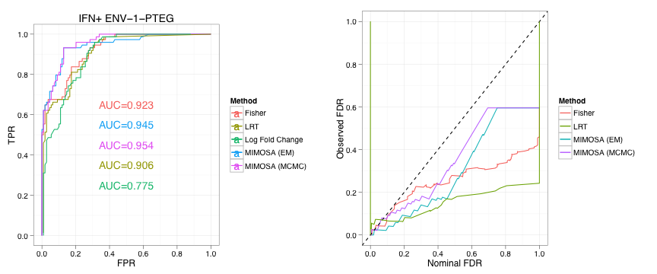;

[x=(foo.south east),y=(foo.north west)] at (0,1) [font=] A ; at (0.5,1) [font=] B ;

; (B)

at (0,0) (bar)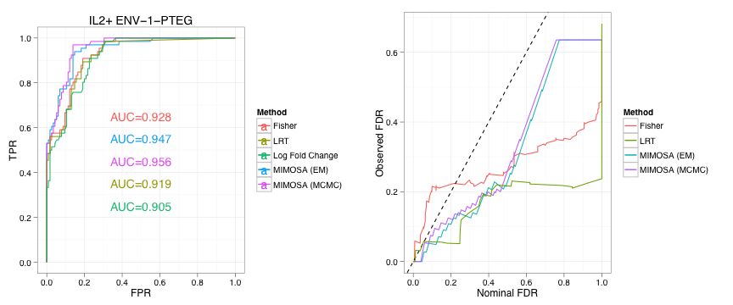;

[x=(bar.south east),y=(bar.north west)] at (0,1) [font=] C ; at (0.5,1) [font=] D ;

; (E)

at (0,0) (baz)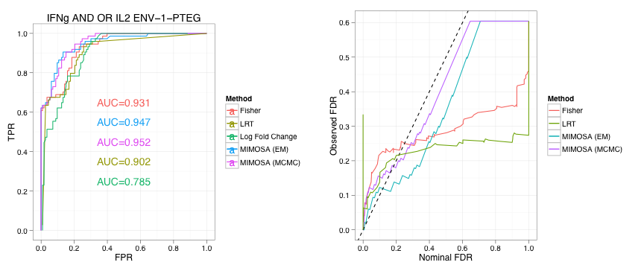;

[x=(baz.south east),y=(baz.north west)] at (0,1) [font=] E ; at (0.5,1) [font=] F ;

;

[fig:HVTN065]

## Single-cell gene expression

We applied the MIMOSA model to Fluidigm single-cell gene expression. This time we used the two-sided MIMOSA model because genes could be up or down regulated upon stimulation. In order to detect stimulation specific changes of expression, our model was fit to each gene within each stimulation. The results presented in Figure [fig:fluidigm] show that MIMOSA identifies stimulation-specific differences in the proportions of cells expressing each gene, while preserving inter-subject variability (Figure [fig:fluidigm] A,B). These patterns are evident in the posterior probabilities (Figure [fig:fluidigm] A), and preserved in the posterior estimates of the differences of proportions (Figure [fig:fluidigm] B). A similar analysis using a two-sided Fisher’s exact test and clustering the signed FDR adjust p-values (Figure [fig:fluidigm] C) does not reveal any stimulation-specific patterns. Comparing the size of the gene sets at an FDR of 10%, Fisher’s exact test identified 47 significant genes while MIMOSA identified 50 significant genes, with 39 genes identified in common between the two methods.

[auto,node distance=0cm] at (0,0) (A)

at (0,0) (foo) 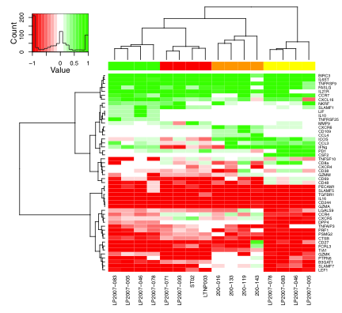;

[x=(foo.south east),y=(foo.north west)] at (0,1) [font=] A ;

; (B)

at (0,0) (bar) 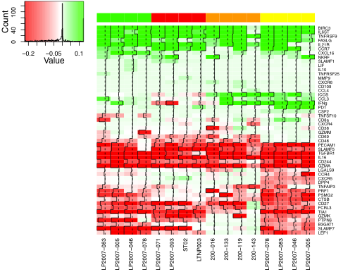;

[x=(bar.south east),y=(bar.north west)] at (-0.1,1.1) [font=] B ;

; (C)

at (0,0) (baz) 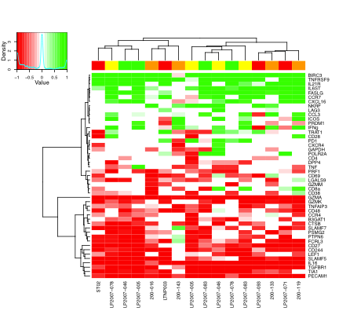;

[x=(baz.south east),y=(baz.north west)] at (0,1) [font=] C ;

;

[fig:fluidigm]

## Simulation Studies

We examined the performance of the constrained () and unconstrained () beta-binomial mixture models via simulations. Using hyper parameters estimated from a one-sided MIMOSA model fit to ICS data (IL2 univariate) from the primary immunogenicity time point. We simulated data from this constrained model with 200 observations, a response rate of 60%, an of 1,000, 5,000, 10,000 events, with ten independent realizations of data for each . The one-sided MIMOSA model was fit to this data and the sensitivity and specificity of the model’s ability to correctly identify observations from the “responder” and “non-responder” groups was evaluated through analysis of ROC curves, and compared against Fisher’s exact test, the likelihood ratio test, and log fold-change. This procedure was repeated for the two-sided models fit to two-sided data (Figure [fig:simulations] A,C). In addition, the nominal *vs.* observed FDR was also examined to assess the ability of each method to properly estimate the FDR (Figure [fig:simulations] B,D).

For both the constrained and unconstrained simulations, MIMOSA out-performed competing methods, including Fisher’s exact test, with respect to sensitivity and specificity even at small values of (Figure [fig:simulations] A and C and Web Figure B, panel E). Additionally, the estimated FDR for MIMOSA more closely reflected the nominal FDR compared to Fisher’s exact test and competing methods (Figure [fig:simulations], panels B, D, and Web Figure B panel F).

[auto, node distance=0cm] at (0,0) (A)

at (0,0) (foo) 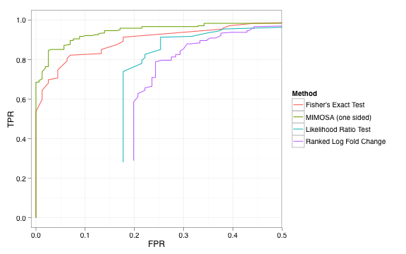;

[x=(foo.south east),y=(foo.north west)] at (0,1) [font=] A ;

; (B)

at (0,0) (bar) 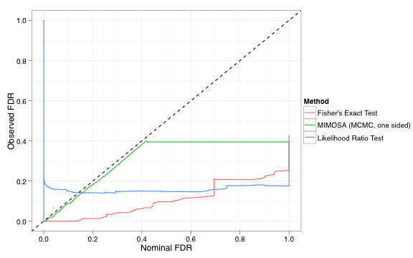;

[x=(bar.south east),y=(bar.north west)] at (0,1) [font=] B ;

; (C)

at (0,0) (c) 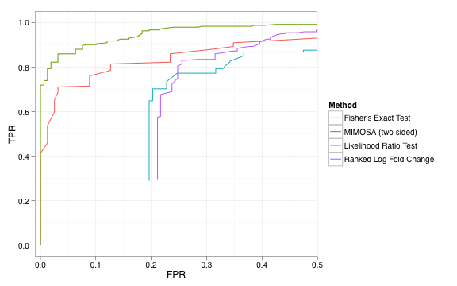;

[x=(c.south east),y=(c.north west)] at (0,1) [font=] C ;

; (D)

at (0,0) (d) ;

[x=(d.south east),y=(d.north west)] at (0,1) [font=] D ;

;

[fig:simulations]

To assess the sensitivity of the model to deviations from model assumptions, we repeated the simulations with the cell proportions drawn from truncated normal distributions on , rather than beta distributions. The means and variances of the truncated normal distributions were set to the maximum likelihood estimates of the beta distributions defined by the hyper parameters estimated from the ICS data set (see Web Figure B panels C and D). Even under these departures from the model assumptions, the unconstrained MIMOSA model outperformed Fisher’s exact test.

# Differential expression across marker combinations

[s:demarkercombos] Our beta-binomial model described in Section [s:DE] can be generalized to a Dirichlet-multinomial model to assess differential expression across multiple marker combinations. As described in the data section, we now have counts for each marker combination, denoted by and .

## Model

In our multivariate model, the beta distribution is replaced by a multinomial distribution, as follows,

$(\mathbf{n}_{ui}|\mathbf{p}_{ui},) \sim \mathcal{M}(N_{ui},\mathbf{p}_{ui})\quad\text{and}\quad (\mathbf{n}_{si}|\mathbf{p}_{si}) \sim \mathcal{M}(N_{si},\mathbf{p}_{si})\label{eq:mult_likeliehood}$

where are the number of cells collected and and are the unknown proportions for the un-stimulated and stimulated samples.

## Prior

As in the one-marker case, we share information across subjects using an exchangeable prior on the unknown proportions. This time the beta priors are replaced by Dirichlet priors, as follows,

$\begin{aligned} (\mathbf{p}_{ui}|z_i=0) &\sim \mathrm{Dir}(\boldsymbol{\alpha}_u)\\\nonumber (\mathbf{p}_{ui}|z_i=1) &\sim \mathrm{Dir}(\boldsymbol{\alpha}_u) \quad \text{and}\quad (\mathbf{p}_{si}|z_i=1) \sim \mathrm{Dir}(\boldsymbol{\alpha}_s)$

where the indicator variable is as defined in Section [ss:priors], i.e. where is the proportion of responders. As in the beta-binomial case both an EM and MCMC algorithms can be used for parameter estimation. When using a fully Bayesian approach via MCMC, we use the same priors for $\boldsymbol{\alpha}_{\{u,s\}}$ and as for the beta-binomial model.

## Parameter estimation

Again, to simplify the estimation problem, we make use of the marginal likelihoods that can be obtained in closed forms (see Web Appendix C). For the null component, the marginal likelihood is given by,

$\begin{aligned} \mathrm{L}_0(\boldsymbol{\alpha}_u|\mathbf{n}_{si},\mathbf{n}_{ui}) &= \frac{ \mathrm{B}(\boldsymbol{\alpha}_{u}+\mathbf{n}_{ui}+\mathbf{n}_{si})}{\mathrm{B}(\boldsymbol{\alpha}_u)} \cdot \frac{N_{si}!}{\prod_k n_{sik}!} \cdot \frac{N_{ui}!}{\prod_k n_{uik}!}\end{aligned}$

where is the -dimensional Beta function defined as $\mathrm{B}(\boldsymbol{\alpha})=\prod_k\Gamma(\alpha_k)/\Gamma(\sum_k\alpha_k)$. Similarly the marginal likelihood for the alternative model is given by   
$\mathrm{L}_1(\boldsymbol{\alpha}_u,\boldsymbol{\alpha}_{si}|\mathbf{n}_{si},\mathbf{n}_{ui}) =\frac{\mathrm{B}(\boldsymbol{\alpha}_{u}+\mathbf{n}_{ui}) \mathrm{B}(\boldsymbol{\alpha}_{s}+\mathbf{n}_{si})}{\mathrm{B}(\boldsymbol{\alpha}_s)\mathrm{B}(\boldsymbol{\alpha}_u)} \cdot \frac{N_{si}!}{\prod_k n_{sik}!} \frac{N_{ui}!}{\prod_k n_{uik}!}.$  
 The estimation procedures (both EM and MCMC based) for the multinonial-Dirichlet are the same as for the beta-binomial model except that the number of parameters to be estimated is larger. The EM algorithm is now initialized with the multivariate Fisher’s exact test. In our experience, the performance of the EM algorithm greatly deteriorates when becomes larger than three. It becomes more dependent on the initial values and can fail to converge in many instances. Although our MCMC algorithm is slightly more computational, it does not suffer from this problem and provides a robust alternative when is large. More details about our multivariate MCMC algorithm is given in Web Appendix C.

## Polyfunctionality in Fluidigm Single-Cell Gene Expression Data

As a proof-of-concept, we fitted our multivariate MIMOSA model looking at two specific genes in the Fluidigm data, namely BIRC3 and CCL5. In this case, and we have four possible combinations. In Figure [fig:polyfunctionality] we show heatmaps of the counts of cells expressing all combinations of the BIRC3 and CCL5 genes in unstimulated and stimulated samples (Figure [fig:polyfunctionality] A,B). Only CCL5 positive cells express BIRC3, and its expression increases upon stimulation. The typical approach to analyzing poly-functional populations from intracellular cytokine staining data (summing the counts over all possible polyfunctional cell populations as in IL2 and/or IFN) would not be appropriate in this case, since changes in the counts of these different cell populations occur in both directions. That is to say, the number of BIRC3-/CCL5+ cells decreases upon stimulation and the number of BIRC3+/CCL5+ cells increases. When marginalizing over these cell populations, no difference is apparent in any of the samples. In contrast, multivariate MIMOSA tests all polyfunctional cell subpopulations simultaneously, identifying significant differences between stimulated and unstimulated conditions in 13 of the 16 samples (Figure [fig:polyfunctionality] D, black labels). Testing all combinations simultaneously is an advantage over performing multiple univariate tests on the subject combinations, which requires multiplicity adjustment and a potential loss of power.

[auto, node distance=0cm] at (0,0) (A)

at (0,0) (foo) 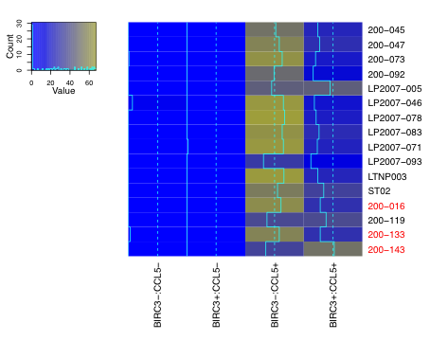;

[x=(foo.south east),y=(foo.north west)] at (0,1) [font=] A ;

; (B)

at (0,0) (bar) 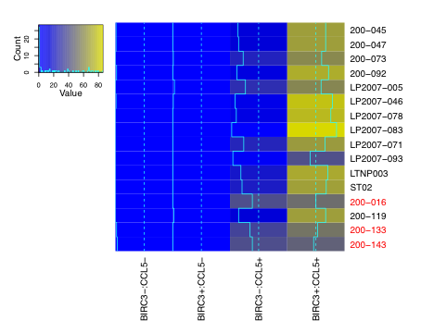;

[x=(bar.south east),y=(bar.north west)] at (0,1) [font=] B ;

;

[fig:polyfunctionality]

Since the Fluidigm data has a limited number of observations (100 cells and 16 samples), we could not look at more than two makers at once. Therefore, we performed simulations in eight dimension to assess the power of the multivariate MIMOSA model compared to Fisher’s exact test on the resulting 2x8 tables, as well as the likelihood ratio test (Figure [fig:mvsimulations] A-C). These results show that multivariate MIMOSA has significantly increased power to detect true differences in multivariate data, even with small counts and small effect sizes, and the model is a better fit to the data than other standard approaches tested for analyzing such multivariate count data (Figure [fig:mvsimulations] B).

[auto, node distance=0cm] at (0,0) (A)

at (0,0) (foo) 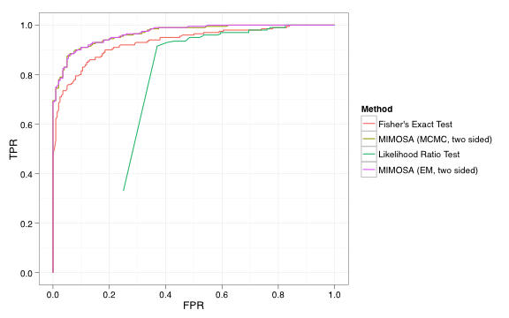;

[x=(foo.south east),y=(foo.north west)] at (0,1) [font=] A ;

; (B)

at (0,0) (bar) 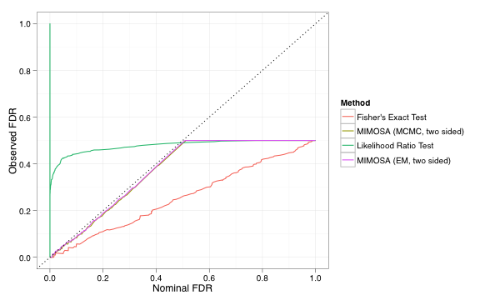;

[x=(bar.south east),y=(bar.north west)] at (0,1) [font=] B ;

;

[fig:mvsimulations]

# Discussion

[s:discussion] Experimentalists have already access to a myriad of single-cell assays such as flow cytometry, mass cytometry and multiplexed quantitative-PCR, to name a few. Single-cell assays will become even more routine once sequencing at the single-cell level becomes practical . As a consequence, the development of effective statistical methods to detect differences in gene or protein expression at the single-cell level is becoming increasingly important. Current approaches for single-cell assays are for the most part simplistic (t-test, test, Fisher’s exact test), and resulting inference can be quite sub-optimal especially when the cell counts are small. Most importantly, these methods do not share information across samples, resulting in less power to detect true differences than empirical-Bayes and hierarchical modeling approaches, which are widely applied in the microarray literature . In addition, most of these methods are univariate in nature and inappropriate for high dimensional next generation single-cell assays.

The MIMOSA model presented here uses a mixture model framework of beta-binomial or Dirichlet-multinomial distributions to model counts in experimental subjects across multiple conditions (*i.e.* vaccine responders and non-responders). Information is shared across responders and non-responders through exchangeable beta or Dirichlet priors, increasing the power to detect true differences between treatment and control conditions compared to Fisher’s exact test, even when the underlying model assumptions are violated (Figures [fig:simulations] and Web Figure B). The univariate MIMOSA model based on the Beta-Binomial distribution allows us to constrain the alternative hypothesis to the case , where the proportion of cells in the stimulated sample is strictly greater than the proportion of cells in the matched unstimulated sample. This has proven to be useful for the ICS data where stimulation induced changes are expected to be one-sided.

Although we used two single-cell assay platforms as motivating examples, our MIMOSA model can be applied to any type of single-cell assay where cells are dichotomized into positive and negative sets, counted and compared across different conditions. In the case of the Fluidigm data, most analysis methods have been focused on identifying differences in the continuous part of the signal ignoring cells that are undetected (*i.e.* the gene is not expressed in the cell), or the information is used for pre-filtering . The ability of MIMOSA to identify stimulation-specific expression patterns in single-cell gene expression data demonstrates not only the broader utility of the method, but importantly, also demonstrates that biologically relevant signal is present in the proportion of cells expressing each gene under different conditions (Figure [fig:fluidigm] A-C).

Detecting differences in poly-functional cell populations (*i.e.* identifying changes in cell populations that co-express multiple proteins, cytokines, or genes), is important in immunology, since it allows the identification of more precisely defined, more homogeneous cell populations . In the context of HIV, these poly-functional cell populations have been shown to be correlated with good outcome such as vaccine protection and long-term disease non-progression . In the ICS data used here, the stimulation is expected to only increase the number of antigen specific cells detected. It follows that if a specific cell subset expressing multiple markers is being differentially expressed, differential expression based on the marginal cell counts should also be detected. As such, identifying poly-functional cytokine profiles from ICS data can be done in an iterative way. First univariate tests on marginal populations are performed and then specific cell subsets expressing the positive markers detected are then tested. Even in this situation, this iterative (univariate) approach might not be satisfactory due to the large number of possible combinations that needs to be tested, and a multivariate approach might be preferable. In this case, as others have pointed out, in order to have the most power to detect a true difference, the statistical test should be selected taking into account only the cytokine combinations of interest .

When changes are two-sided, as with the Fluidigm data, changes in poly-functional cell populations are not always detectable when looking at the marginal populations (Figure [fig:polyfunctionality] A-C). In this case, the use of multivariate model, as our Dirichlet-multinomial model, will become important to detect differential marker expression. Here we have shown that MIMOSA has higher sensitivity and specificity than these competing methods to identify true differences between conditions in multivariate count data (Figure [fig:polyfunctionality] A, and Figure [fig:mvsimulations] A,C), and the model generally provides a better fit to the single-cell assay count data arising from studies with these types of experimental designs (Figure [fig:mvsimulations] B). Unfortunately, the limited number of samples in the Fluidigm data prevented us from looking at co-expression involving more than two genes. In the case of more than two markers, there is a combinatorial explosion in the number of parameters involved in our multinomial-Dirichlet mixture model. The number of parameters to be estimated is , which can become very large even for moderate values of . As an example, leads to 33 parameters, and this would require one to have a large number of subjects to properly estimate all parameters. A solution would be to explore alternative model parameterizations that could be used to reduce the number of required parameters. For example, one could assume that the hyper-parameters are constant across marker combinations, *i.e.* for all , and the number of parameters would be reduced to for any . As attractive as this might sound, such a model would be unrealistic given that certain stimulations are known to induce expression of certain markers more than others. More exploratory work will need to be done in this area once high dimensional single-cell level data with large number of samples become available.

All of the results presented here were obtained with a software implementation of the EM and MCMC MIMOSA models in R and C++, and is freely available from GitHub (<http://www.github.org/gfinak/MIMOSA>). An R package will soon be released as part of the Bioconductor project .

# Supplementary Materials

Web Appendices A, B, C, and Web Figures A and B referenced in Sections [s:data] and [s:DEone],[s:estimation], and [s:demarkercombos] are available in the attached Web-based supplementary material.

# Acknowledgments

GF and RG acknowledge funding from National Institute of Health grants R01 EB008400 and U01 AI068635-01, and a Bill & Melinda Gates Foundation grant OPP1032317.

[lastpage]

1. Add a bit more info here, how many genes, tetramer sorted, etc, Mario et al. could you fill this in?